The following is an example of a press advisory to issue when you are hosting an event such as a press conference, mobility day, or celebration of enactment. It should be sent to all local media, especially those that have been covering the process.

Contact: Kyle Stepp
Contact number: 317-389-0131

MEDIA ADVISORY
Press conference and reception for HB-131, So New Mexicans Can Move

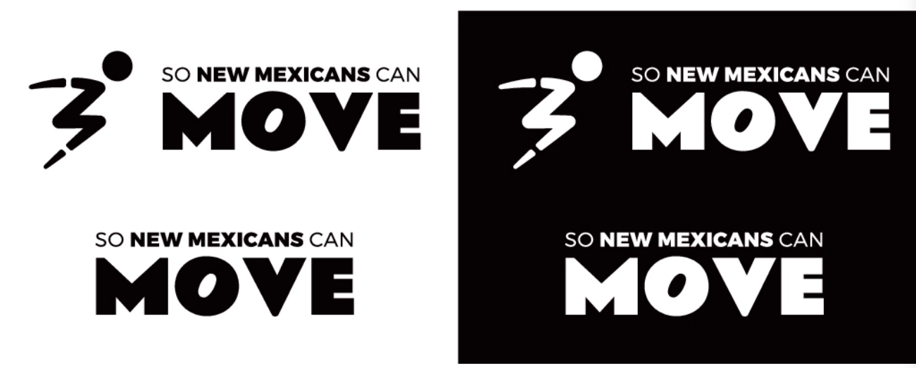
WHAT: HB- 131, So New Mexicans Can Move was signed into law by Governor Michelle Lujan Grisham. This historical piece of legislation is one of the most comprehensive O&P coverage bills for the limb loss and limb difference community in the nation. The bill ensures O&P care is covered at the same level as Medicare, expands access to orthotics and prosthetics necessary for physical activity for all ages, defines medical necessity and non-discrimination standards for coverage of O&P, and prohibits unfair trade practices on the basis of disability.

The bill sponsors included: Rep. Liz Thomson (D-24), Rep. Kathleen Cates (D-44), Rep. Joshua Hernandez (R-60), Rep. John Block (R-51), Sen. Siah Correa Hemphill (D-28), and Rep. Gail Armstrong (R-49). It received support from both Presbyterian Health Plan and Blue Cross Blue Shield.
This is a celebration of this life-changing piece of legislation, honoring the team of advocates, community partners, and legislative sponsors. These individuals will be on hand to answer any questions.
WHO:
Kyle Stepp, So New Mexicans Can Move Lead Advocate
Representative Liz Thomson
Senator Siah Correa Hemphill
Representative Kathleen Cates
Representative Joshua Hernandez
Representative John Block
Brandon Fryar, Presbyterian Health Plan President

WHEN: Friday, April 28, 2023, 12:00-12:30 Press conference, followed by a Reception from 12:30 – 1:30

WHERE: Presbyterian Rev. Hugh Cooper Administrative Center, 9521 San Mateo Blvd NE, Albuquerque, NM 87113

CONTACT: Kyle Stepp
317-389-0131
Kylestepp94@gmail.com

