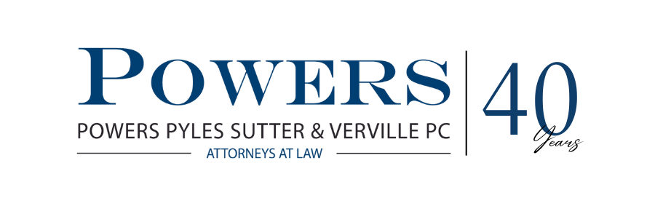

**MEMORANDUM**

TO: So Kids Can Move Coalition

FROM: Peter Thomas and Hannah Comeau

DATE: February 23, 2023

SUBJECT: Application of ACA Section 1557 to SKCM Legislation Age Distinctions

**Introduction**

You have asked us to provide guidance concerning Section 1557 of the Patient Protection and Affordable Care Act (“ACA”) and its applicability to the age-limited orthotics and prosthetics legislation in Maine, New Hampshire, Colorado, and Indiana. Section 1557 is the primary anti-discrimination provision of the ACA and prohibits discrimination in certain health programs or activities on the basis of race, color, national origin, age, disability, or sex. We also considered other aspects of the ACA that pertain to nondiscrimination in essential health benefit (EHB) plan design, specifically Section 156.125 of the federal EHB regulations. The So Kids Can Move (SKCM) initiative seeks to pass state legislation that expands the scope of O&P coverage in the private insurance market for children and young adults by covering activity-specific prostheses and custom orthoses. Other model versions of this legislation apply to private insurance enrollees of all ages. The decision as to which approach to pursue usually turns on the facts and circumstances within each state where SKCM legislation is being considered.

The SKCM legislation in Maine, New Hampshire, Colorado, and Indiana is age limited in that it restricts the benefits to children 18 years of age or younger, and thus prompts the question of whether the ACA’s prohibition of age discrimination conflicts with or invalidates this legislation. In short, the answer is complicated. While the limitation to children does not appear to violate Section 1557, any such limitation must be evidence-based in order to pass muster under the EHB nondiscrimination section barring discrimination based on age.

**Application of 1557**

Section 1557 has broad application, covering any plan that (1) receives federal financial assistance from the government and (2) is principally engaged in the provision or administration of certain health programs or activities. These qualifying programs or activities are described in paragraph (a) of the proposed definition of “health program or activity” under proposed § 92.4, which includes “providing or administering health-related services, health insurance coverage, or other health-related coverage.”[1]

Currently, there is a proposed rule which addresses the anti-discrimination portions of 1557[2] and this rule is expected to be issued in final form later this spring. The proposed rule contains a subsection entitled “Health Equity and Discrimination Related to Age” and primarily serves the function of highlighting populations that are most at risk of age-related discrimination in health care. These groups include children and the elderly, especially if a person falling into one of these age brackets is also a member of a racial minority or a lower socioeconomic status. The proposed rule does not suggest any substantive changes to the applicability of 1557 in the context of age discrimination as outlined in the preceding paragraph.

**The Enactment of a State Benefit Mandate for a Specific Age Group Does Not Violate Section 1557**

Under Section 1557, it is permissible for the federal government – or states – to adopt new laws that incorporate age distinctions. One example of permissible age-distinctive laws on the federal level is the Early and Periodic Screening, Diagnostic, and Treatment (“EPSDT”) benefit under Medicaid. This program provides comprehensive, preventative health care for Medicaid enrollees under the age of 21. Similar to this example, the SKCM legislation in Maine, New Hampshire, Colorado, and Indiana—each of which contain an age-based limitation—do not appear to run afoul of Section 1557. In fact, an HHS Frequently Asked Question (FAQ) clarifies that the Section 1557 regulations “do not apply to age distinctions contained in State or local statutes that were adopted by an elected, general purpose legislative body.”[3] In other words, the SKCM legislation would not violate Section 1557 “because it is authorized under State law.”[4] However, this FAQ was published in 2017.

**Prohibition on Discrimination** **Involving EHB**. § 156.125

While the SKCM legislation containing age restrictions does not violate Section 1557 of the ACA, other, more specific nondiscrimination requirements also apply to Essential Health Benefit design and these requirements pertain to, among other things, age. For instance, Section 156.125 of the ACA states:

(a) An issuer does not provide EHB if its benefit design, or the implementation of its benefit design, discriminates based on an individual's age, expected length of life, present or predicted disability, degree of medical dependency, quality of life, or other health conditions. Beginning on the earlier of January 1, 2023 (the start of the 2023 plan year) or upon renewal of any plan subject to this rule, a non-discriminatory benefit design that provides EHB is one that is clinically-based.[5]

These EHB age discrimination provisions prohibit age distinctions if the service or treatment is clinically effective for all ages, which is a clear challenge to the SKCM’s limitation to children of the expanded scope of activity-specific prostheses and custom orthoses. Clearly, adults can benefit from activity-specific O&P care as well as children. The EHB regulations in footnote 483 also offer categorical examples of presumptive age discrimination including the following:

(1) limitation on hearing aid coverage based on age;

(2) autism spectrum disorder coverage limitations based on age;

(3) age limits for infertility treatment coverage when treatment is clinically effective for the age group;

(4) limitation on foot care coverage based on diagnosis (whether diabetes or another underlying medical condition); and

(5) access to prescription drugs for chronic health conditions (adverse tiering)).

The first example listed above pertaining to hearing aid coverage is very similar to coverage of activity-specific O&P care for children only. The SKCM legislation purports to expand the scope of an existing EHB benefit, custom orthotics and prosthetics, the benefit category for which is listed in the ACA as “rehabilitative and habilitative services and devices.” Creating a benefit mandate not considered to be included in EHB would require the state to supplement the cost of this new benefit. Therefore, we must maintain that activity-specific prostheses are included in EHB and, therefore, the benefit design to cover these benefits must not discriminate based on age under this regulatory provision. This argument can be used by SKCM to argue to states that they must apply this new scope of the existing O&P benefit to privately-insured people *of all ages*.

If, however, we wish to assert that the state can, in fact, limit this benefit to children in order to achieve passage in the first place by limiting the costs of this provision, we must develop an evidence base to demonstrate why the limitation to children is justified. Unless SKCM can develop a clinical rationale for coverage of this benefit for children, we will have problems with these age discrimination EHB regulations. There is evidence that suggests that children who are not active and exposed to sports and athletic activities before age 12 are far less likely to exercise and stay fit later in life. This and perhaps other research involving childhood obesity and the long-term implications of a sedentary lifestyle at a young age could formulate a clinically-based rationale for limiting this benefit to children without violating the EHB age discrimination requirements.

**Conclusion**

The SKCM campaign should develop an evidence base to argue that the legislation to expand the scope of activity-specific prostheses and orthoses can be limited to children only, without violating Section 156-125 of the ACA regulations. If successful, this will enable SKCM to have maximum flexibility when working with each state’s legislature to determine how far it is willing to go to expand the scope of the O&P benefit under private insurance plans, either to children alone or to enrollees of all ages.

1. [Federal Register :: Nondiscrimination in Health Programs and Activities](https://www.federalregister.gov/documents/2022/08/04/2022-16217/nondiscrimination-in-health-programs-and-activities) at 47,826-27.
2. [Federal Register :: Nondiscrimination in Health Programs and Activities](https://www.federalregister.gov/documents/2022/08/04/2022-16217/nondiscrimination-in-health-programs-and-activities).
3. [Section 1557: Frequently Asked Questions | HHS.gov](https://www.hhs.gov/civil-rights/for-individuals/section-1557/1557faqs/index.html); (published May 18, 2017).
4. [Section 1557: Frequently Asked Questions | HHS.gov](https://www.hhs.gov/civil-rights/for-individuals/section-1557/1557faqs/index.html).
5. HHS Notice of Benefit and Payment Parameters for 2023, Final Rule; [87 FR 27208](https://www.federalregister.gov/citation/87-FR-27208), [27301-05](https://www.federalregister.gov/citation/87-FR-27301), May 6, 2022